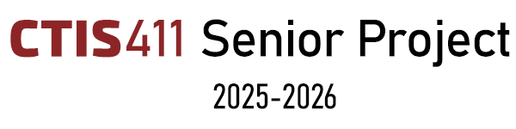

**Initial Plan**

**Vacanza – AI Powered Travel Application**

**Team 2**

**Ahmet Serhat Şahin, 22101813**

**Damla Alçay, 22002369**

**Göksu Uzun, 22102745**

**Ömer Faruk Asil, 22002781**

**Ufuk Zencirci, 22102476**

Bilkent University

Department of Information Systems and Technologies

16.11.2025

Change History

|  |  |  |  |  |
| --- | --- | --- | --- | --- |
| **File Name** | **Document Type** | **Deliverable** | **Version** | **Submission Date** |
| Team2_InitialPlan_V1 | Microsoft Word 2024 Document (.docx) | 1 | 1 | 05.10.2025 |
| Team2_InitialPlan_V2 | Microsoft Word 2024 Document (.docx) | 1 | 2 | 16.11.2025 |

Change List

* In “Risks” part, risks are minimized (two of them omitted) and risk matrix has been edited according to the changes. Unnecessary implementations have been removed.
* “Executive Summary” part, were rewritten to remove redundant project descriptions, focus on what the document contains rather than the product itself, reflect the updated structure of all sections and integrate the revised functional and non-functional requirements in line with the instructor’s expectations.
* All VACANZA typos turned into Vacanza.
* Since the “SDLC” section does not require information about the product itself, we removed that part from the text. We reorganized the section to focus solely on the selected process model and how we applied it throughout the project.
* In “WBS” section, ID’s were added and the figüre is removed to avoid repetitive implementation.
* “GANTT Chart for Vacanza” were updated according to the Vacanza’s own milestones. Also, SCRUM logic were explicitly shown.
* “Milestones for Vacanza” table were updated according to GANTT chart, and Gamification were deleted.
* In the “Project Stakeholders and Organization” section, the stakeholder descriptions were restructured from a paragraph format into a bullet-point list to improve readability. The content was also divided into two separate subheadings: Stakeholders, which identifies the project stakeholders, and Project Organization, which explains the team structure and workflow. The roles of the stakeholders were briefly clarified to simplify the text.
* In “Project Communication” part, the detailed list of sub-teams and their roles (Frontend & Map, Backend, Mobile, AI, Gamification) were removed as advised. These details were transferred to the “Project Stakeholders and Organization” section to avoid redundancy and maintain logical structure.
* “Project Change Control” part  were restructured into two subsections, Code Base and Documentation Change Control, to clarify and formalize the project’s change management process
* In "Assumptions" part, the entire paragraph is converted into items under main headings.
  + The word will is replaced with the word shall.
  + Gamification part is removed since there will be no real users in the gamification.
  + Bussines case is removed.
* In the “Product Requirements” section, all requirements were rewritten to match a more formal and concise structure. Each statement now follows the IEEE SRS convention using *shall*, *should*, and *may* to clearly indicate priority and obligation levels.
  + Functional requirements were refined to focus only on core project functionalities directly related to stakeholder needs (travelers, advisor, and external API providers). Simple or low-level features were intentionally omitted.
  + Descriptions were shortened and simplified to improve clarity while preserving purpose and stakeholder connection. Some functions were kept as optional features to reflect prototype constraints.
  + Non-functional requirements were minimized to the two most relevant aspects for the prototype stage (*Usability* and *Security*) aligning with the advisor’s feedback.

Project Details

|  |  |
| --- | --- |
| **Project Name** | **Vacanza - AI Powered Travel Application** |
| **Software Product Name** | **Vacanza** |
| **Company Name** | **No sponsor company** |
| **Academic Advisor** | **Neşe Şahin Özçelik** |
| **Github URL** | [**https://github.com/VacanzaTravelApp**](https://github.com/VacanzaTravelApp) |
| **WEB page** | [**https://www.vacanza.app**](https://www.vacanza.app/) |
| **Software Product Information** | Vacanza is an AI-powered travel assistant that helps users plan their trips in a smart, personalized, and effortless way. The application uses artificial intelligence to design customized travel routes based on each user’s interests, preferences, and travel style—whether they enjoy culture, food, history, or nature. Vacanza combines everything a traveler needs in one place: cultural and event recommendations, interactive 2D/3D maps, booking connections for flights and accommodation, and calendar synchronization for easy scheduling. Thanks to its AI system, Vacanza can also adapt plans dynamically according to weather, time, or local events, and provide instant suggestions through a friendly chatbot. In short, Vacanza turns travel planning into a smooth, intelligent, and enjoyable experience by offering a truly personalized journey for every user. |

Team 2

|  |  |  |
| --- | --- | --- |
| **Name, Surname** | **Bilkent e-mail** | **Alternative e-mail** |
| Ahmet Serhat Şahin | serhat.sahin@ug.bilkent.edu.tr | aserhatsahin@gmail.com |
| Damla Alçay | damla.alcay@ug.bilkent.edu.tr | alcaydamla2@gmail.com |
| Göksu Uzun | goksu.uzun@ug.bilkent.edu.tr | goksuzun@gmail.com |
| Ömer Faruk Asil | faruk.asil@ug.bilkent.edu.tr | asilo02@hotmail.com |
| Ufuk Zencirci | ufuk.zencirci@ug.bilkent.edu.tr | ufuq.zencirci@gmail.com |

Individual Contributions Overview

|  |  |
| --- | --- |
| **Name, Surname** | **Summary of Contributions to the Initial Plan Document** |
| Ahmet Serhat Şahin | Executive Summary  Project Communication  Project Change Control  Software Product Information |
| Damla Alçay | Software Development Lifecycle  Project Stakeholders and Organization |
| Göksu Uzun | Discussions  General Format  Project Requirements  Risks |
| Ömer Faruk Asil | Milestones & Deliverables  Project Scope  Work Breakdown Structure |
| Ufuk Zencirci | Assumptions  Product Purpose |

Executive Summary

The Initial Plan document outlines the complete foundation of the Vacanza project by presenting its purpose, system expectations and planned development activities for the academic year. The Product Purpose section explains Vacanza as an AI assisted travel planning system that unifies route generation, cultural exploration, booking redirection and map based interaction into a single cohesive platform. The document then introduces the functional requirements in a consolidated form, describing the system’s key capabilities such as AI driven personalization, interactive mapping, dynamic itinerary updates, booking and calendar integrations, cross platform consistency and supplementary features that support user engagement and contextual exploration. The non functional requirements focus on usability and performance, emphasizing accessible design and responsive system behavior during core operations. Additional sections define project constraints and limitations, supported by a context diagram that illustrates Vacanza’s interaction with users and external services. The Software Development Process Model describes the use of Scrum across two semesters, with documentation centered activities in the first term and sprint based implementation, testing and review cycles in the second. The Project Scope lists all planned tasks including analysis, design, development, AI and AR components, testing and documentation, which are further organized into a hierarchical Work Breakdown Structure. Milestones and deliverables are aligned with the academic calendar to form a clear timeline. The document identifies internal and external stakeholders, outlines the team’s collaborative organization and details the communication structure using tools such as Mattermost, WhatsApp, Zoom, Google Docs, GitHub and Jira. Formal procedures for code and documentation management are summarized in the Change Control section. Assumptions regarding technology availability, data reliability and user environment are listed, followed by a risk analysis that evaluates key threats using probability and consequence values. The Discussions section reflects on challenges encountered during preparation, including workload balance, formatting consistency and requirement clarification, while noting how iterative collaboration improved coherence across the document. Overall, the Initial Plan provides a comprehensive and organized framework that defines Vacanza’s objectives, requirements, development methodology and execution roadmap for the upcoming design and implementation phases.[1]

Table of Contents

**Page Number**

1. Product Purpose 1

2. Product Requirements 2

2.1 Functional Requirements 2

2.2 Non-Functional Requirements 3

2.3 Exclusions and Limitations 3

3. Software Development Process Model 5

4. Project Scope 7

4.1 Work Breakdown Structure 8

4.2 Milestones & Deliverables 10

5. Project Stakeholders and Organization 12

6. Project Communication 13

7. Project Change Control 15

8. Assumptions 16

9. Risks 17

10. Discussions 19

11. Curriculum Vitae 20

List of Tables

**Page Number**

Table 1 Milestones for Vacanza 10

List of Figures

**Page Number**

Figure 1 Context Diagram for Vacanza 4

Figure 2 Scrum Process Cycle for Vacanza 6

Figure 3 GANTT Chart for Vacanza 11

Figure 4 Risk Matrix for Vacanza 18

Abbreviations

|  |  |
| --- | --- |
| CTIS | Information Systems and Technologies |
| FReq | Functional Requirements |
| NFReq | Non-Functional Requirements |
| NFT | Non-Fungible Token |
| R | Risk |
| SDD | Software Design Description Document |
| SDLC | Software Development Lifecycle |
| SPMP | Software Product Management Plan Document |
| SRS  WBS | Software Requirements Specification Document  Work Breakdown Structure |
|  |  |
|  |  |
|  |  |
|  |  |
|  |  |
|  |  |

# Product Purpose

Travel planning today is fragmented and inefficient, as users must rely on multiple platforms such as Google Maps, Booking, or TripAdvisor to manage flights, accommodation, cultural activities, and navigation. This scattered process leads to wasted time, confusion, and missed opportunities for cost savings and optimization. Existing platforms provide only generic recommendations and fail to adapt to user preferences such as culture, history, food, dietary needs, or travel styles. Moreover, current tools rarely integrate AI to provide real-time guidance, dynamic route adjustments, or interactive visualization. They also lack seamless schedule management, since events and reservations are not automatically added to calendars or supported with reminders. These inefficiencies highlight the business need for an integrated, AI-powered travel assistant that centralizes planning, personalizes experiences, and delivers adaptive itineraries for a smoother and safer journey.[2]

The objective of Vacanza is to deliver a unified travel planning platform that combines AI-based personalization, integrated booking for flights, hotels, and events, smart calendar synchronization, and interactive 2D/3D map visualization. The system aims to achieve measurable outcomes. It will also provide real-time chatbot assistance capable of resolving common travel-related queries without human intervention, ensuring a faster and more reliable user experience. Unlike competing products such as Google Maps, Booking, or TripAdvisor, which focus on isolated aspects of travel, Vacanza differentiates itself by offering a fully integrated and adaptive ecosystem. This approach not only reduces planning time and user effort but also enhances satisfaction through personalized experiences, increases engagement with AI-driven features such as reminders and map-based route creation.Additionally, Vacanza incorporates gamification elements such as travel achievements and progress rewards to enhance user motivation and engagement throughout the planning experience.[3]

# Product Requirements

## Functional Requirements

**FReq1 – User Account Creation and Login:**  
The system shall allow travelers to create accounts, verify their email addresses, and log in securely using valid credentials.

**FReq2 – AI-Based User Behavior Modeling:**  
The system shall analyze user interactions and automatically learn behavioral patterns to improve future travel recommendations.

**FReq3 – Personalized AI Route Generation:**  
The system shall generate personalized travel routes based on user preferences such as interests, budget, duration, and travel style.

**FReq4 – Real-Time Map Overlay Filters:**  
The system shall allow users to enable or disable selected map layers (e.g., food, culture, museums, nightlife) in 2D/3D mode.

**FReq5 – Adaptive Itinerary Adjustment:**  
The system shall automatically update itineraries when user-reported conditions change, such as closures or schedule conflicts.

**FReq6 – Accommodation and Transportation Integration:**  
The system shall fetch flight, hotel, and transportation options from external APIs and display filtered results with booking redirection.

**FReq7 – Smart Calendar Synchronization:**  
The system shall synchronize trip events and milestones with the user’s personal calendar and generate automated reminders.

**FReq8 – Gamified Travel Experience:**  
The system may reward users with points, badges, and achievements based on completed routes, visited locations, and check-ins.

**FReq9 – Micro-Location Based Check-In System:**  
The system may detect user arrival within a defined GPS radius and automatically log check-ins for progress tracking and rewards.

**FReq10 – Augmented Reality (AR) Exploration:**  
The system may provide an AR mode that overlays nearby POIs onto the camera view with distance labels and markers.

**FReq11 – Currency Converter & Local Cost Forecasting:**  
The system shall fetch real-time exchange rates and convert prices into the traveler’s preferred home currency.

**FReq12 – Multi-Platform Consistency:**  
The system shall synchronize user data seamlessly between web and mobile platforms without data loss or delay.

**FReq13 – Administrative Insight and Monitoring:**  
The system may provide a web-based admin dashboard showing API status, user activity metrics, and system monitoring data.

**FReq14 – Custom Area Selection and POI Integration:**  
The system shall allow users to draw/select areas on the map and automatically retrieve all POIs within the region for route inclusion.[4]

## Non-Functional Requirements

**NFReq1 – Usability:**  
The system shall provide an intuitive, consistent, and visually clear interface that allows travelers to complete core tasks efficiently, with responsive interactions, reduced user errors, and accessible design across both web and mobile platforms.

**NFReq2 – Performance:**  
The system shall maintain responsive performance during route generation, map rendering, chatbot interaction, and data retrieval, supporting multiple concurrent users, stable API communication, and acceptable response times during prototype demonstrations.

## Exclusions and Limitations

**C1 – Commercial Deployment Excluded**: The current version of Vacanza is developed solely for academic purposes within the CTIS Senior Project framework. Therefore, commercial release, monetization, or public app store deployment are excluded from the project scope.

**C2 – Limited Data Source Coverage**: The accuracy and completeness of travel data (e.g., events, accommodations, routes) depend on external APIproviders such as Amadeus or Mapbox. Inaccurate, missing, or delayed data from these sources may limit the reliability of recommendations.

**C3 – AI Model Constraints**: The AI-based recommendation engine operates on cloud-based APIs and pretrained models. It may not perform complex contextual reasoning beyond its training data, and temporary service interruptions could affect real-time suggestions.

**C4 – Integration Dependency**: Any service or API changes introduced by third-party providers (e.g., pricing policies, endpoint deprecations, or quota limits) **may temporarily restrict**Vacanza’s functionality until integrations are updated.[5]

Figure Context Diagram for Vacanza

# Software Development Process Model

For our senior project, we chose the Scrum framework of the Agile Software Development Lifecycle. Scrum allows for incremental and iterative development, which makes it ideal for complex, multi-component systems that require continuous adaptation and feedback. In the first semester, we focus on documentation such as requirement analysis, system and database design, test planning, and backlog creation, with progress monitored through meetings every three days. In the second semester, we move on to coding with weekly sprints that include development, testing, and review. Each sub-team — Frontend & Map, Backend, Mobile, AI, and Gamification — holds internal meetings to coordinate tasks and resolve blockers efficiently.[6] The Product Owner and Scrum Master roles are both undertaken by Ömer Faruk Asil, who manages the backlog, facilitates meetings, removes obstacles, and ensures adherence to Scrum principles. The development team, consisting of Göksu Uzun, Damla Alçay, Ahmet Serhat Şahin, and Ufuk Zencirci, collaborates across all layers of the project, including frontend and backend development, UI/UX design, and testing. Their combined efforts ensure effective communication, balanced workload distribution, and consistent implementation of Scrum practices throughout the project lifecycle. The main advantage of adopting Scrum in this project is the ability to deliver early prototypes, gather user feedback rapidly, and maintain flexibility when integrating external APIs, such as for accommodation or transportation services in later sprints. [7]However, the primary challenge is managing daily scrums during the second semester while balancing a heavy academic workload, which requires careful time management and discipline. Our prior exposure to Agile methods through coursework and internships, along with the use of Jira, GitHub Projects, and Figma, supports the effective and structured execution of the Scrum process in Vacanza.

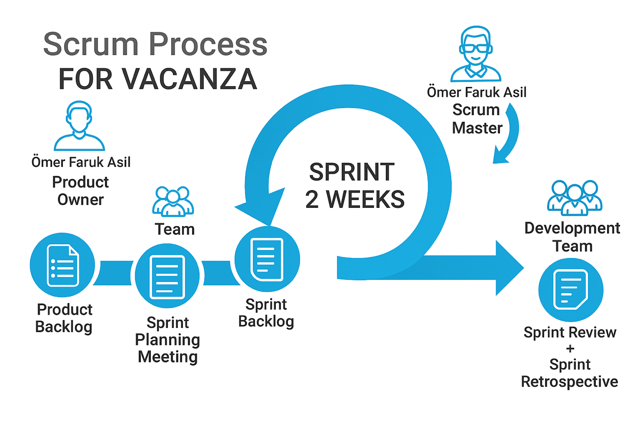

Figure Scrum Process Cycle for Vacanza

# Project Scope

This project will be carried out over two semesters during the 2025–2026 academic year and will be completed in May 2026. Within the project scope, analysis, design, development, testing, and delivery activities will be performed.

The goal is to complete the planned activities within the given timeframe and deliver a working prototype along with documentation and presentations.

**In-Scope**

* Requirements analysis and identification of user needs
* System architecture and user interface design
* Development of web (React) and mobile (Flutter) applications
* Backend development (Spring Boot)
* AI module development (Python-based route planning and recommendation system)
* Map integration (Mapbox)
* Calendar and notification system integration
* Accommodation & transportation booking redirection (via 3rd party providers)
* AR development
* Gamification development
* End-user testing (scenarios, demo tests, acceptance tests)
* Documentation: Initial Plan, SRS, SPMP, SDD
* Deliverables: First Increment Product, Final Product, Final Presentation

**Out of Scope**

* Commercial launch, marketing, and sales activities
* NFT or blockchain integration: Achievements may be implemented as digital cards, but their conversion into blockchain-based NFTs will not be carried out within this scope. This may be considered in the future to increase user motivation. Additionally, in later versions, NFT-based cards for a limited number of users completing specific “challenge” tasks may also be designed.
* Full-scale real-world operation (the project is limited to prototype and testing phases)

**Constraints**

* Time: The project will be completed in May 2026.
* Resources: Student team, limited budget, and hardware.
* Technologies: React (web), Flutter (mobile), Spring Boot (backend), Python (AI), PostgreSQL, Firebase, MongoDB, Docker, Mapbox. Optional: Amadeus API or equivalent. Cloud infrastructure: DigitalOcean droplet.

**Expected Outcomes**

* Functional web and mobile prototype
* AI-supported route planning and recommendation system
* Map and calendar integration
* Booking redirection module
* AR module integration
* Achievement module
* Documentation: Initial Plan, SRS, SPMP, SDD
* First Increment Product, Final Product
* Final presentation

## Work Breakdown Structure

* **Project Management**

WBS1.1. Preparation of Initial Plan

WBS1.2. Preparation of SPMP

WBS1.3. Process tracking & reporting

* **Requirements Analysis**

WBS2.1. Collecting user needs

WBS2.2. Preparing use case diagrams

WBS2.3. Preparation of SRS

* **Design (Architecture & UI/UX)**

WBS3.1. System architecture (Spring Boot, React, Flutter, PostgreSQL)

WBS3.2. Database design

WBS3.3. User interface prototypes

WBS3.4. AR prototype design

WBS3.5. Gamification design

WBS3.6. Preparation of SDD

* **Development**

WBS4.1. Backend development (Spring Boot, PostgreSQL, API)

WBS4.2. Frontend development (React Web, Flutter Mobile)

WBS4.3. AI module development (Python-based route planning & recommendations)

WBS4.4. AR prototype development

WBS4.5. Gamification development

WBS4.6. General travel API integration

WBS4.7. Cloud infrastructure setup (DigitalOcean)

* **Testing & Verification**

WBS5.1. End-user testing

WBS5.2. Acceptance testing

WBS5.3. Prototype demo testing

* **Deliverables & Presentations**

WBS6.1. Initial Plan (Deliverable 1)

WBS6.2. SRS (Deliverable 2)

WBS6.3. SPMP (Deliverable 3)

WBS6.4. SDD (Deliverable 4)

WBS6.5. First Increment Product (end of fall semester)

WBS6.6. Final Product (May 2026)

WBS6.7. Final Presentation (May 2026)

## Milestones & Deliverables

Table Milestones for Vacanza

|  |  |
| --- | --- |
| **Milestones** | **Expected Date** |
| Initial Plan Submission | Mon, **Oct 6, 2025** |
| SRS Submission | Mon, **Nov 10, 2025** |
| SPMP Submission | Mon, **Dec 1, 2025** |
| SDD Submission | Mon, **Jan 5, 2026** |
| First Prototype (≈20% of Final) | Between **Dec 17 - Dec 24** |
| 1st Increment Presentation | Between **Dec 26 – Jan 8** |
| Development Completion | Fri, **May 15, 2026** |
| Testing Completion | Fri, **May 15, 2026** |
| Final Presentation | Mid-**May 2026** |

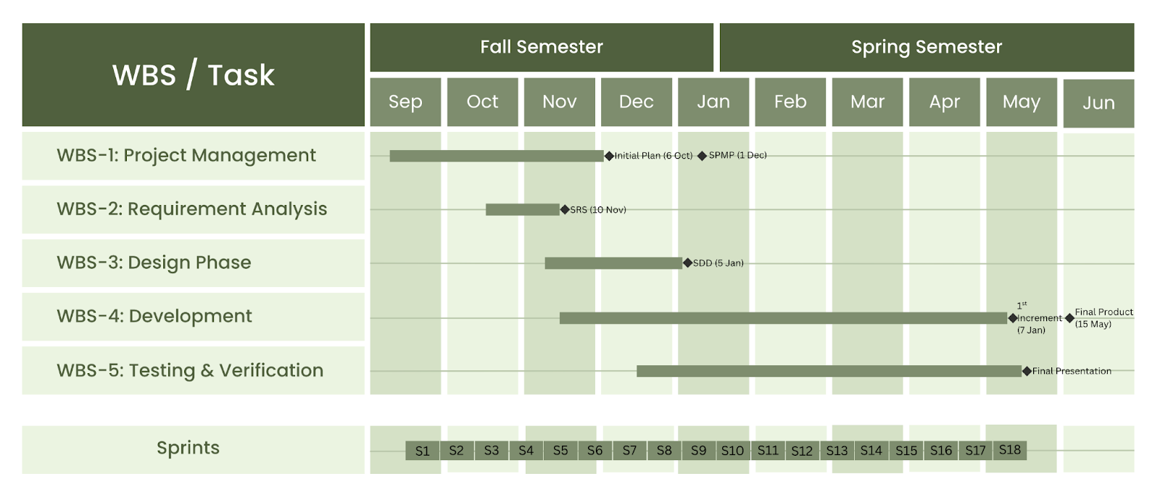

Figure GANTT Chart for Vacanza

# Project Stakeholders and Organization

**Project Stakeholders**

The stakeholders of our project consist of both internal and external groups:

* **Internal Stakeholders:**
  + **Developers, designers, and testers** are responsible for building and improving the Vacanza application.
  + **Scrum Master** organizes meetings, removes obstacles, and ensures the team’s progress according to Scrum principles.
  + **Product Owner** manages the product backlog, prioritizes requirements, and reports progress to the project advisor.
  + **Team Members** handle frontend and backend development, database management, AI-based recommendation system integration, and testing.
* **External Stakeholders:**
  + **End Users (Travelers):** individuals who use the app to create personalized cultural travel plans.
  + **External API Providers:** services such as maps, hotels, tickets, and car rentals that are essential for application functionality.
  + **Project Advisor:** oversees the project’s progress, provides academic feedback, and offers continuous mentorship to ensure the project aligns with course objectives.

**Project Organization**

Our project follows a Scrum-based collaborative structure. The Product Owner communicates requirements to the team and reports updates to the Project Advisor. The Scrum Master supports the team by facilitating meetings and ensuring adherence to Scrum methodology, while development team members share progress and challenges during daily scrum meetings.

The reporting structure is flat, with responsibilities distributed equally among all members. This structure enhances efficiency by minimizing hierarchy and promoting accountability. Maintaining active communication with the Project Advisor and effectively managing external integrations ensures smooth collaboration and minimizes risks, contributing to the project’s successful completion.

# Project Communication

* **Team Structure and Meetings**

Project communication for Vacanza is structured to ensure both efficiency and clarity across all stakeholders throughout both semesters. During the first semester, these meetings take place every three days, focusing on reviewing completed tasks, identifying blockers, and planning upcoming work. In the second semester, as the project progresses into implementation and testing, the team plans to increase the frequency of daily meetings, ensuring closer tracking of tasks and quicker resolution of issues. In addition, Sprint Review meetings are held every four weeks to evaluate progress, demonstrate completed features, and receive feedback from stakeholders. All meetings (daily and review sessions) are conducted through Zoom to ensure accessibility and clear communication among all members.

* **Communication Platforms**

Formal communication within the team is primarily conducted through Mattermost, which serves as the main platform for discussions, document sharing, and meeting notes. In addition, communication with the project advisor is maintained through a dedicated WhatsApp group, which is used to arrange meeting times, receive feedback, and share urgent updates or clarifications. Advisor meetings are held regularly, and summarized notes are documented to capture decisions and action items. For day-to-day coordination among team members, a separate WhatsApp group is used without the advisor; while considered informal, it remains strictly project-focused and complements the formal records. All meeting notes—whether internal or involving stakeholders—are documented collaboratively through Google Docs, ensuring accessibility, version control, and transparency in decision-making.

* **Tool Integration and Notifications**

To strengthen transparency, all activity on the GitHub repository (commits, pull requests, merges) is automatically notified to the Mattermost channel, allowing the team to monitor codebase changes in real time. Similarly, Jira is integrated with Mattermost so that newly created tasks, updates, and completed issues are instantly shared with the group. These automated notifications ensure that every team member remains informed and project progress is tracked consistently.

Altogether, this layered communication structure—combining team-wide and sub-team meetings, Sprint Reviews, advisor contact, integrated tools, and centralized documentation—ensures that all stakeholders remain informed, decisions are well-documented, and the project advances in an organized and transparent manner.[8]

# Project Change Control

**Code Base Change Control**

The branching and workflow strategy will include:

* **Branch:** Contains only tested and approved versions as the stable release.
* **Production Branch:** Serves as the integration branch where completed features are collected and prepared for testing.
* **Test Branch:** Validates changes from production; only successful tests allow merging into main.
* **Feature Branches:** Created from production and named after the Jira task ID (e.g. feature/FEA-123-user-login), then merged back into production once complete.

To enforce quality, merges into production must be performed by a team member other than the branch creator (peer review), while merges into test and main are restricted to the designated responsible person (e.g., team leader). All pull requests will be linked to their Jira task for proper tracking.

Issue and task management will be handled in Jira, where every change request will be opened, assigned, and tracked until completion. Commit messages in GitHub will reference the corresponding Jira Task ID to ensure alignment between code changes and documentation.

**Documentation Change Control**

* Draft documents will be prepared collaboratively on Google Docs.
* Official versions (e.g., Initial Plan V1, SPMP V2, Final Report V1) will be stored in GitHub to guarantee version tracking and a single source of truth.

By applying this structured approach, the project ensures that all changes—both in code and documentation—are properly identified, reviewed, authorized, and recorded throughout both semesters.[9]

# Assumptions

* **Technology Availability**

It is assumed that AI models, such as GPT-based recommendation systems, shall continue to be available and accessible through general travelling APIs. Additionally, 2D/3D mapping technologies and integration libraries such as Mapbox or Google Maps API shall remain stable, reliable, and affordable throughout the project’s development and operation.

* **Third-Party Dependencies**

The project depends on reliable third-party vendors, including the Amadeus API for flights, hotels, and car rentals. It is also assumed that future integrations with external platforms such as Booking, Expedia, or Trivago shall be technically feasible and permitted under acceptable licensing terms.

* **Data Reliability**

It is assumed that event, transportation, and accommodation data retrieved from external APIs shall remain accurate, up-to-date, and complete, ensuring that users receive trustworthy and consistent travel information.

* **User Environment**

 It is expected that travelers shall have access to smartphones or web platforms with stable internet connections. Furthermore, it is assumed that most users shall grant calendar and notification permissions to enable reminders, alerts, and automatic schedule synchronization.[10]

# Risks

For the Vacanza project, each risk was analyzed according to its probability (Pf), consequence (Cf), and overall risk factor (RF) values using the following formulas:

$$Pf = (Pm + Pc + Pd) ÷3$$

$$Cf =\left(Cc + Cs + Cr + Cp\right)÷ 4$$

$$RF= Pf + Cf - (Pf × Cf)$$

**Rule of Thumb:**

Low Risk: RF < 0.30 | Medium Risk: 0.30 ≤ RF ≤ 0.70 | High Risk: RF > 0.70

**R1 – Absenteeism**

**Pf = 0.56, Cf = 0.67, RF = 0.80 → High Risk**

* **What is likely to happen (probability and impact):** Uneven workload or coordination issues may occur, especially during overlapping documentation and implementation periods. This could delay certain deliverables and reduce overall efficiency.
* **What can be done to minimize it:** Clear task distribution, weekly progress check-ins, and transparent responsibility tracking via Mattermost and GitHub will reduce imbalance.
* **What cues should be monitored:** Missed internal deadlines, unreported progress, or repeated task extensions.
* **Likely outcomes and reactions:** Temporary workload imbalance and time pressure, mitigated through workload redistribution among team members.

**R2 – Requirements Not Fully Satisfied**

**Pf = 0.44, Cf = 0.56, RF = 0.70 → Medium Risk**

* **What is likely to happen (probability and impact):** Some features may not fully meet user expectations due to time limitations or scope misinterpretation.
* **What can be done to minimize it:** Conduct frequent requirement validation sessions with the advisor, utilize feedback loops, and maintain a detailed backlog in Jira.
* **What cues should be monitored:** Inconsistent feedback, feature rework requests, or conflicting implementation notes.
* **Likely outcomes and reactions:** Partial feature reimplementation or adjusted milestones; lessons integrated into sprint retrospectives.[11]

Figure Risk Matrix for Vacanza

# Discussions

While preparing this Initial Plan, our team faced several challenges. The main difficulty was dividing the tasks into equal parts, since some sections required more effort and time than others. Although the distribution was not always balanced, members who finished their own parts earlier actively supported others, which helped us maintain overall progress. Importantly, no team member was absent, and collaboration remained consistent throughout the process.

Another challenge was strictly following the formatting rules of the template, which was time-consuming and sometimes confusing. Sections that required figures or diagrams, such as the context diagram and the risk matrix, also took additional time and coordination to complete.

Furthermore, defining the project scope and finalizing the requirements was more complex than expected. Since some features overlapped between functional areas (e.g., AI, AR, and gamification), multiple iterations and team discussions were required to ensure that each part aligned with the overall system vision.

After individual parts were completed, combining and reviewing all contributions to maintain consistency and coherence across the document was another challenging step. Each section needed to match in tone, formatting, and terminology, which demanded several rounds of revisions and merging efforts.

Despite these difficulties, the preparation process was highly valuable. It improved our coordination, strengthened our understanding of project planning, and helped clarify both task ownership and the logical flow between deliverables. Ultimately, the team gained a deeper understanding of the project’s requirements, identified potential risks early, and established a clear and realistic roadmap for the next phase.[12]

# Curriculum Vitae

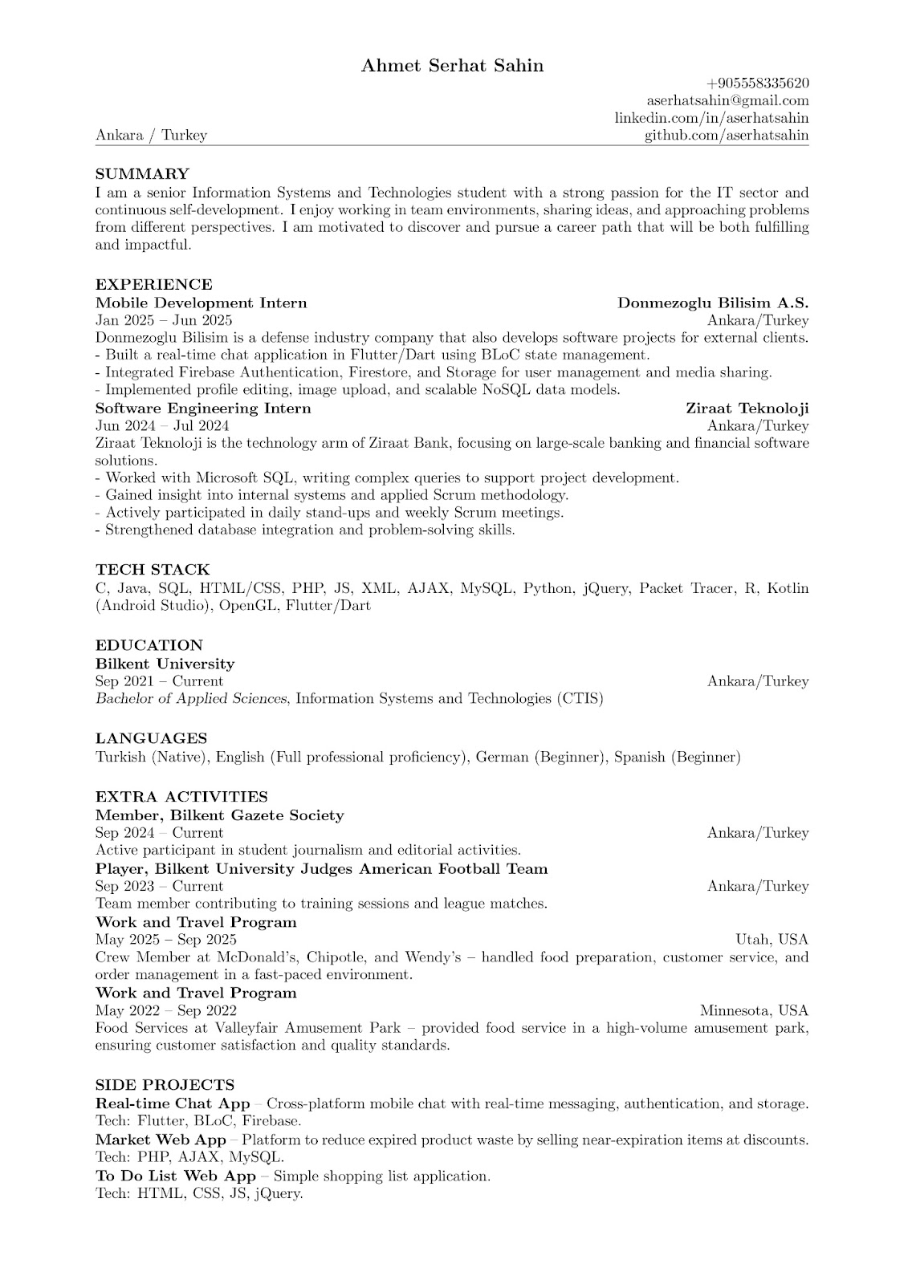

1. ChatGPT 5 Prompt: “**Initial Plan dokümanımızı inceleyip önceki formatı koruyarak dokümandaki güncellemeleri ve değişiklikleri dikkate alarak kısa bir executive summary yaz Dokümanın neyi içerdiğini hangi bölümlere odaklandığımızı ve bulgularımızı tek bir paragrafta açıkla”**
2. ChatGPT 5 Prompt: “**I want you to understand the project completely so you can help me create ideas, write technical documentation, and prepare professional texts later (like product purpose, objectives, assumptions, reports, etc.)”**
3. ChatGPT 5 Prompt: “**Help me write the Product Purpose section based on these headings: Reasons, objectives of product, product to be delivered, comparison with competitors and product purpose.”**
4. ChatGPT 5 Prompt: **“*all the updated freqs from srs are given* can you write all the freqs in order in given format”**
5. ChatGPT 5 Prompt: “**\*previous requirements and current stakeholders are given* can you list the requirements (usability and performance) according to the stakeholders with using shall, should, may?”**
6. ChatGPT 5 Prompt: “**paraphrase and translate the text and make it sound like formal academic english**.”
7. ChatGPT 5 Prompt: “**write a short summary for me and I’m going to paraphrase it**”
8. ChatGPT 5 Prompt: “**here is how our team communicates and manages the project with tools like zoom jira github mattermost and google docs as well as sprint reviews and regular meetings write this information as a formal project communication section for our ctis initial plan”**
9. ChatGPT 5 Prompt: “**using the info i give about how we handle project changes with mattermost jira github branches and google docs write the project change control part in a clear academic way for our initial plan**”
10. ChatGPT 5 Prompt: “**I am preparing the Assumptions section of my senior project report.  
    Write the Assumptions part in a formal academic paragraph.The section should include: **all the necessary things in the description**”**
11. ChatGPT 5 Prompt: “**here are the possible risks and the equations, can you provide me with the requirements of the description and can you give me exact numbers for me to sketch a matrix**”
12. ChatGPT 5 Prompt: “**\*\*explained all the issues have been faced** can you write them as in the description and in an academic tone**”